Q1. Create a Database as Tree?

Q2. Create a Table as Trunk mentioned as below?

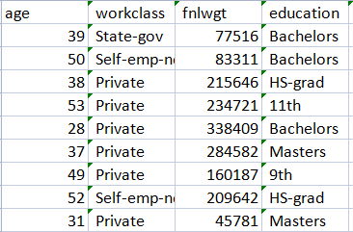

Q3. Delete the record having age as 28?

Q4. Truncate all the records and update the information mentioned below:

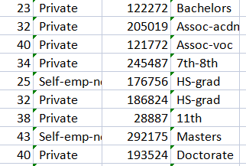

Q5. Update the education of person having age as 25 to Bachelors and workclass as state-government?